PRACTICAL NO.08
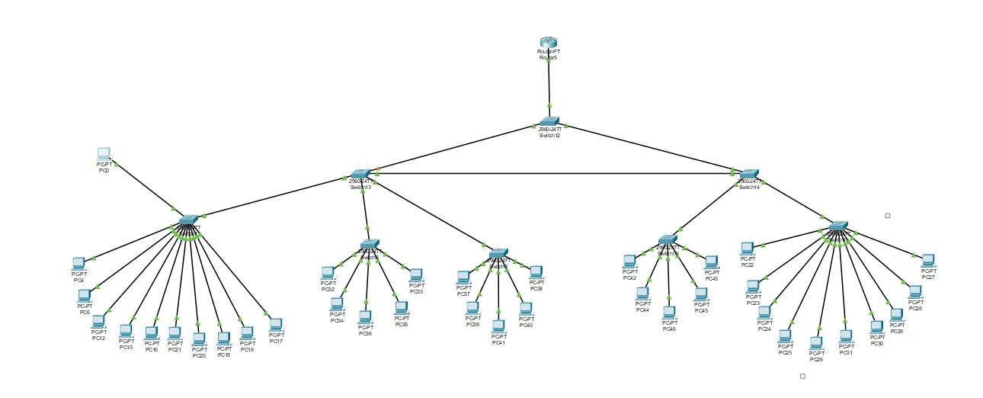
Layer 2 VLAN Security

Addressing Table:
Device | Interface | IP Address | Subnet Mask | Default Gateway | Switch Port
Router0 | Fa0/0 | 142.0.0.76 | 255.255.255.248 | N/A | N/A
Router0 | Fa1/0 | 142.0.0.1 | 255.255.255.248 | N/A | N/A
Router0 | Serial2/0 | 142.0.0.9 | 255.255.255.248 | N/A | N/A
Router0 | Serial3/0 | 142.0.0.81 | 255.255.255.248 | N/A | N/A
Router1 | Fa0/0 | 142.0.0.73 | 255.255.255.248 | N/A | N/A
Router1 | Fa1/0 | 142.0.0.65 | 255.255.255.248 | N/A | N/A
Router1 | Serial2/0 | 142.0.0.90 | 255.255.255.248 | N/A | N/A
Router1 | Serial3/0 | 142.0.0.58 | 255.255.255.248 | N/A | N/A
Router1 | Serial6/0 | 142.0.0.97 | 255.255.255.248 | N/A | N/A
Router2 | Fa0/0 | 142.0.0.25 | 255.255.255.248 | N/A | N/A
Router2 | Fa1/0 | 142.0.0.17 | 255.255.255.248 | N/A | N/A
Router2 | Serial2/0 | 142.0.0.10 | 255.255.255.248 | N/A | N/A
Router2 | Serial3/0 | 142.0.0.98 | 255.255.255.248 | N/A | N/A
Router3 | Fa0/0 | 142.0.0.28 | 255.255.255.248 | N/A | N/A
Router3 | Fa1/0 | 142.0.0.33 | 255.255.255.248 | N/A | N/A
Router3 | Serial2/0 | 142.0.0.89 | 255.255.255.248 | N/A | N/A
Router3 | Serial3/0 | 142.0.0.41 | 255.255.255.248 | N/A | N/A
Router3 | Serial6/0 | 142.0.0.82 | 255.255.255.248 | N/A | N/A
Router4 | Fa0/0 | 142.0.0.49 | 255.255.255.248 | N/A | N/A
Router4 | Serial2/0 | 142.0.0.57 | 255.255.255.248 | N/A | N/A
Router4 | Serial3/0 | 142.0.0.42 | 255.255.255.248 | N/A | N/A
PC2 | Fa0 | 142.0.0.3 | 255.255.255.248 | 142.0.0.1 | Switch3
PC3 | Fa0 | 142.0.0.2 | 255.255.255.248 | 142.0.0.1 | Switch3
PC1 | Fa0 | 142.0.0.18 | 255.255.255.248 | 142.0.0.17 | Switch2
PC0 | Fa0 | 142.0.0.19 | 255.255.255.248 | 142.0.0.17 | Switch2
Server2 | Fa0 | 142.0.0.26 | 255.255.255.248 | 142.0.0.25 | Switch1
PC5 | Fa0 | 142.0.0.27 | 255.255.255.248 | 142.0.0.25 | Switch1
PC8 | Fa0 | 142.0.0.34 | 255.255.255.248 | 142.0.0.33 | Switch4
PC9 | Fa0 | 142.0.0.35 | 255.255.255.248 | 142.0.0.33 | Switch4
PC13 | Fa0 | 142.0.0.50 | 255.255.255.248 | 142.0.0.49 | Switch6
PC14 | Fa0 | 142.0.0.51 | 255.255.255.248 | 142.0.0.49 | Switch6
PC10 | Fa0 | 142.0.0.67 | 255.255.255.248 | 142.0.0.65 | Switch5
PC11 | Fa0 | 142.0.0.66 | 255.255.255.248 | 142.0.0.65 | Switch5
PC7 | Fa0 | 142.0.0.74 | 255.255.255.248 | 142.0.0.73 | Switch0
Server3 | Fa0 | 142.0.0.75 | 255.255.255.248 | 142.0.0.73 | Switch0

Assign and create the vlan:
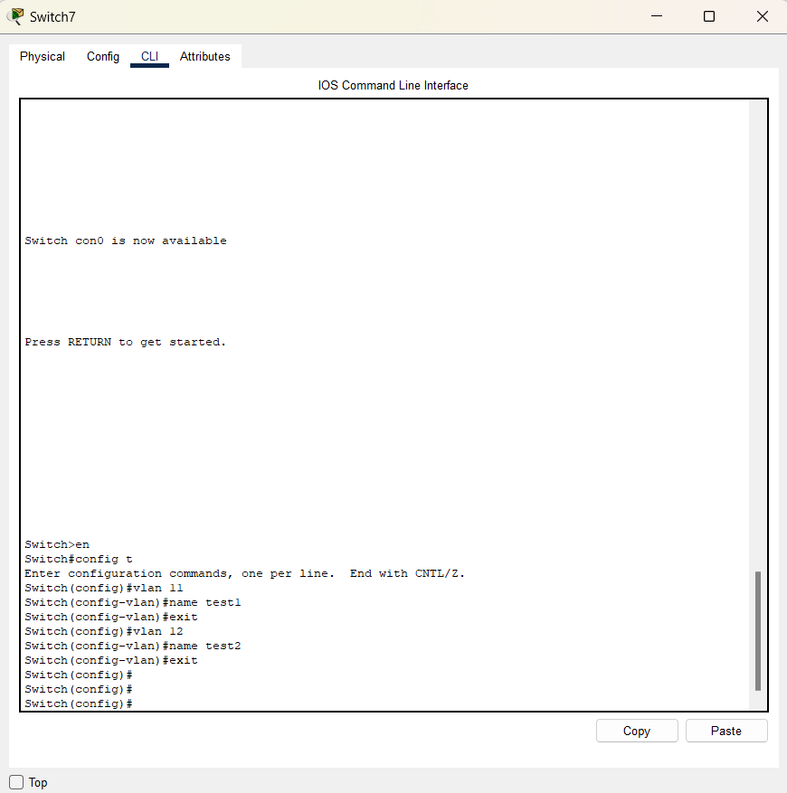
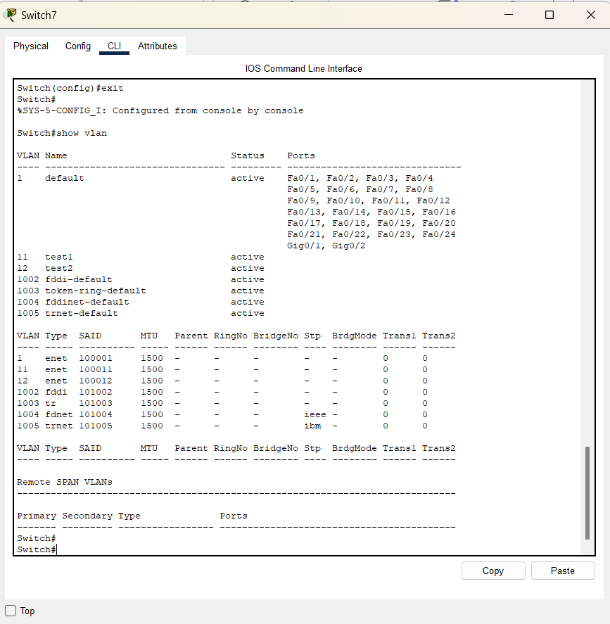
Assign the Access mode on the switch:
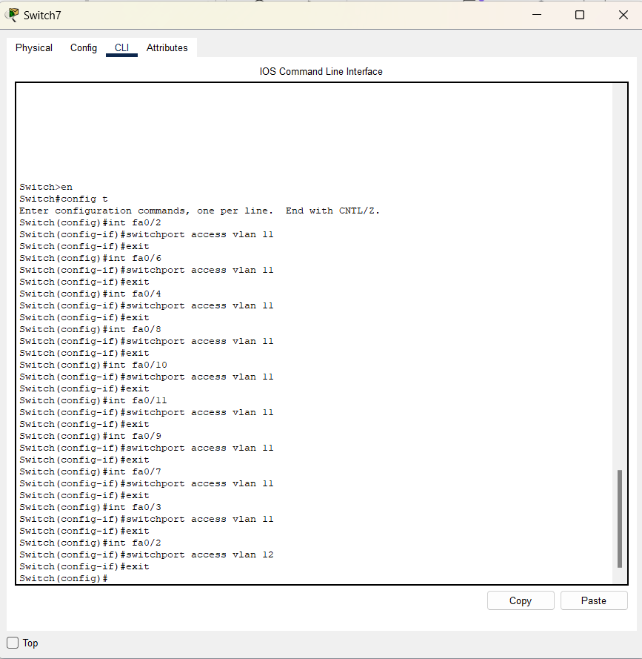
Assign and create the vlan:
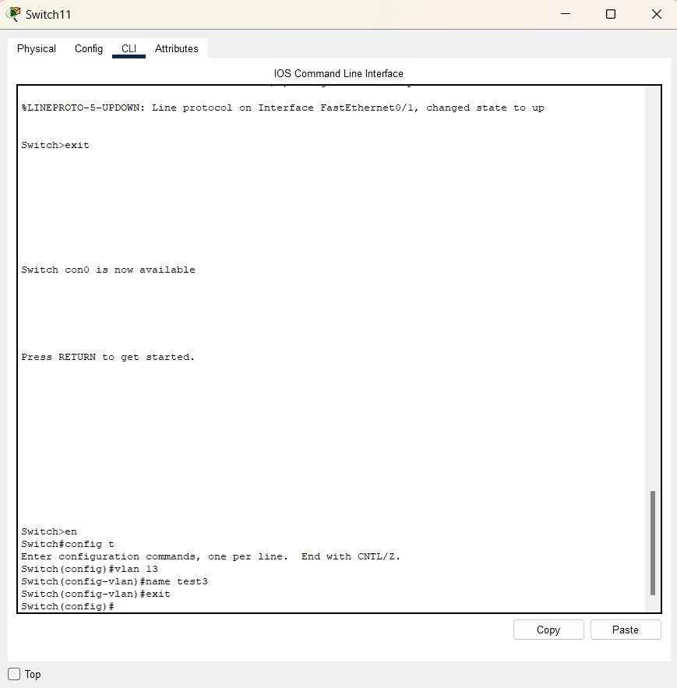

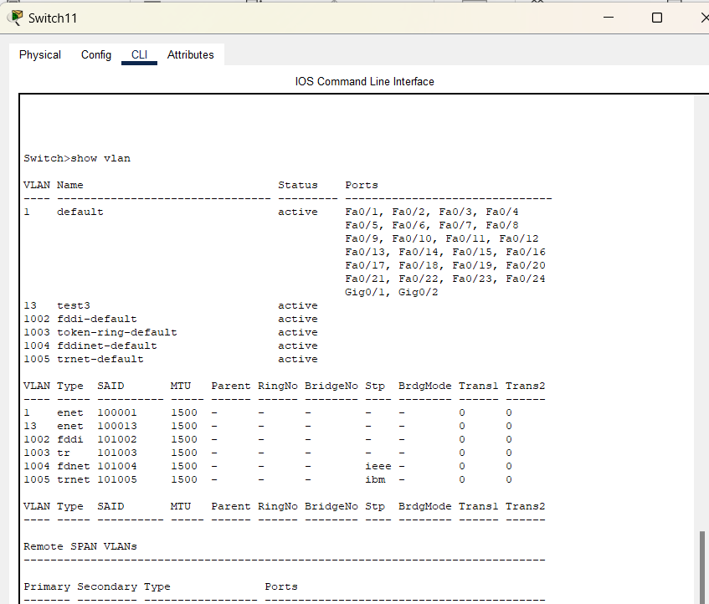

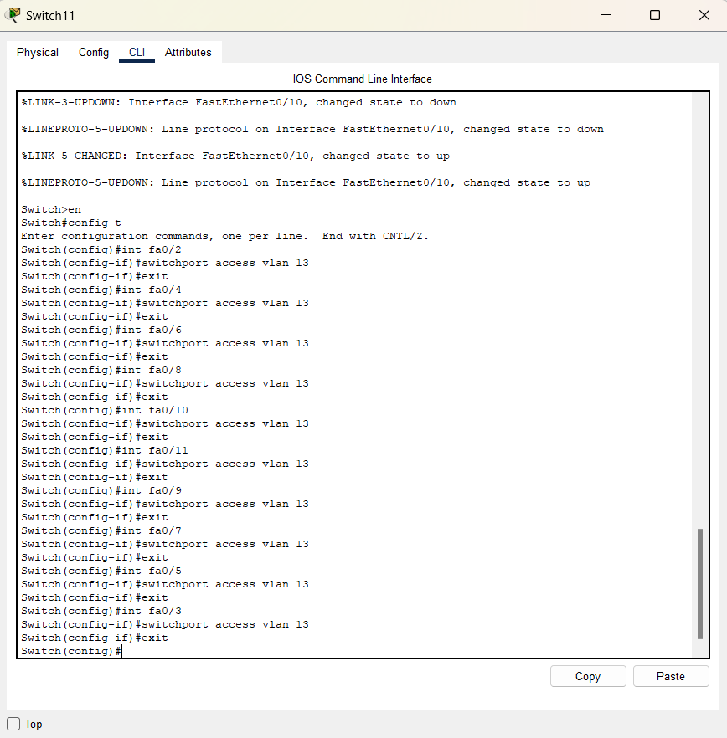
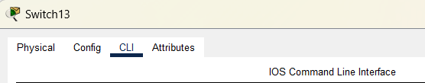
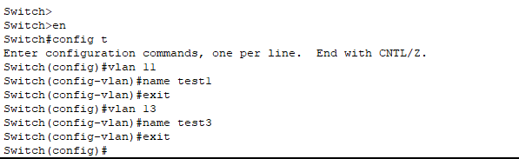

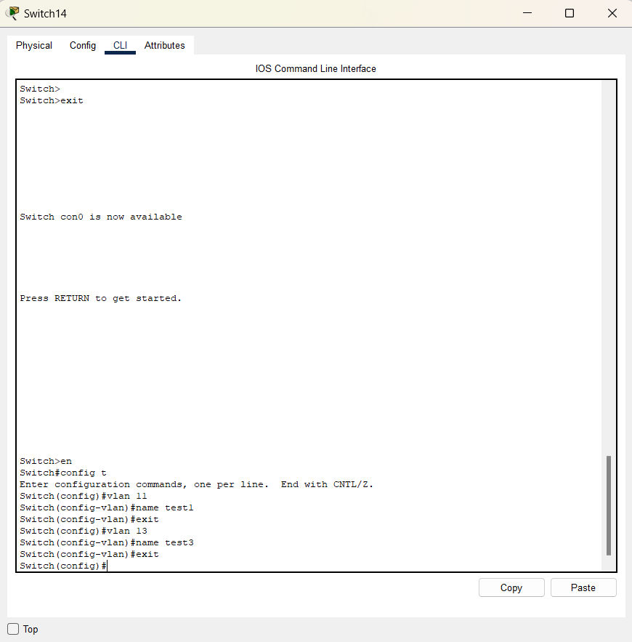
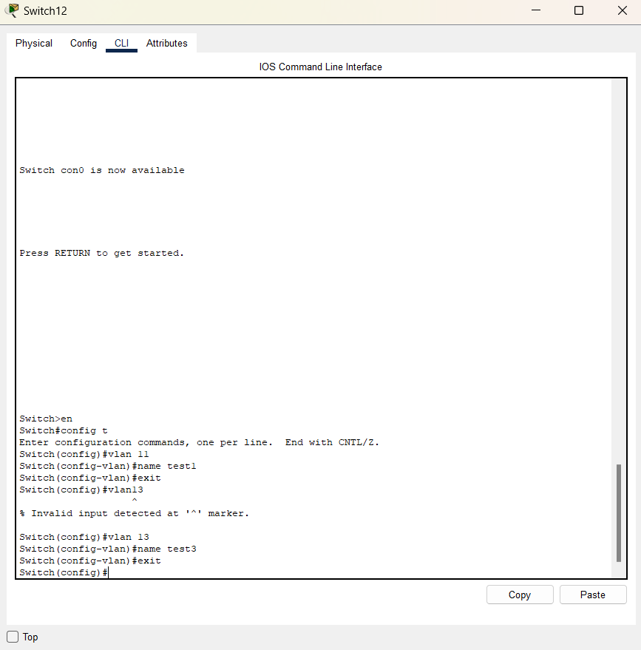

SWITCH11
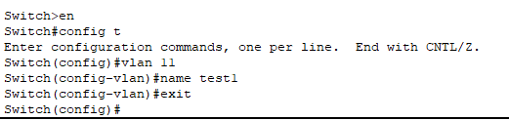
Switch 7
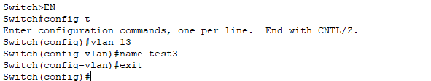
Accessing same vlan :
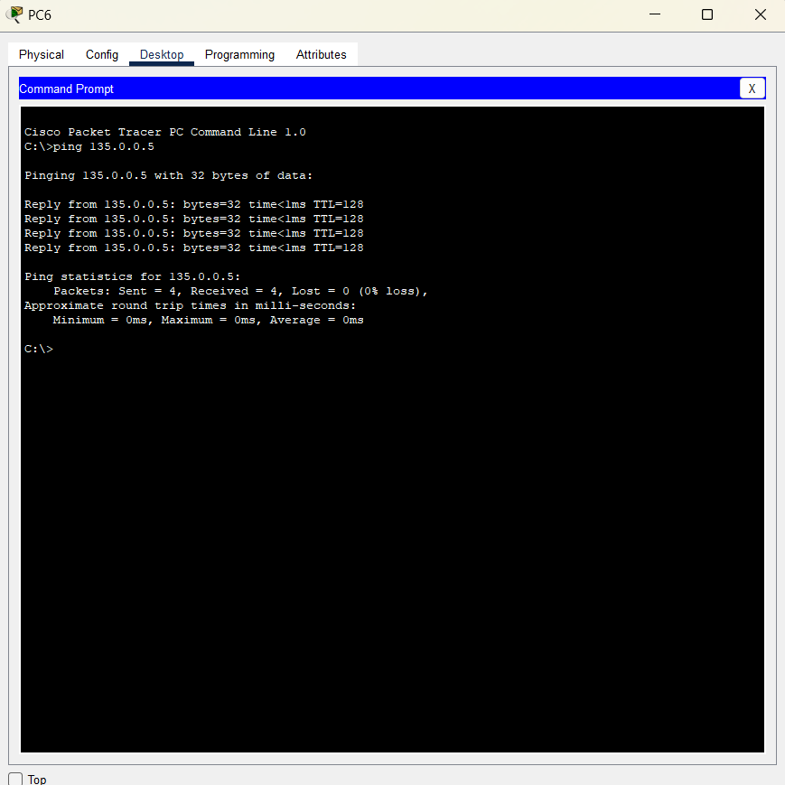

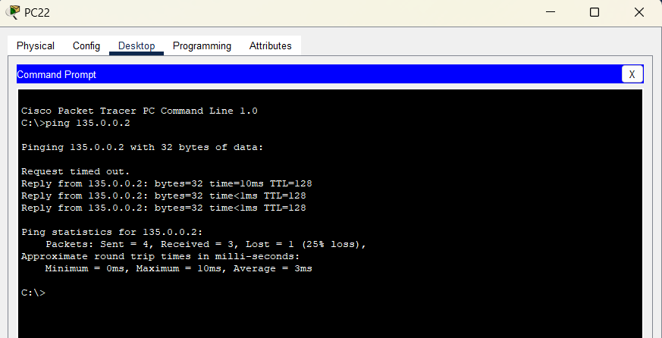

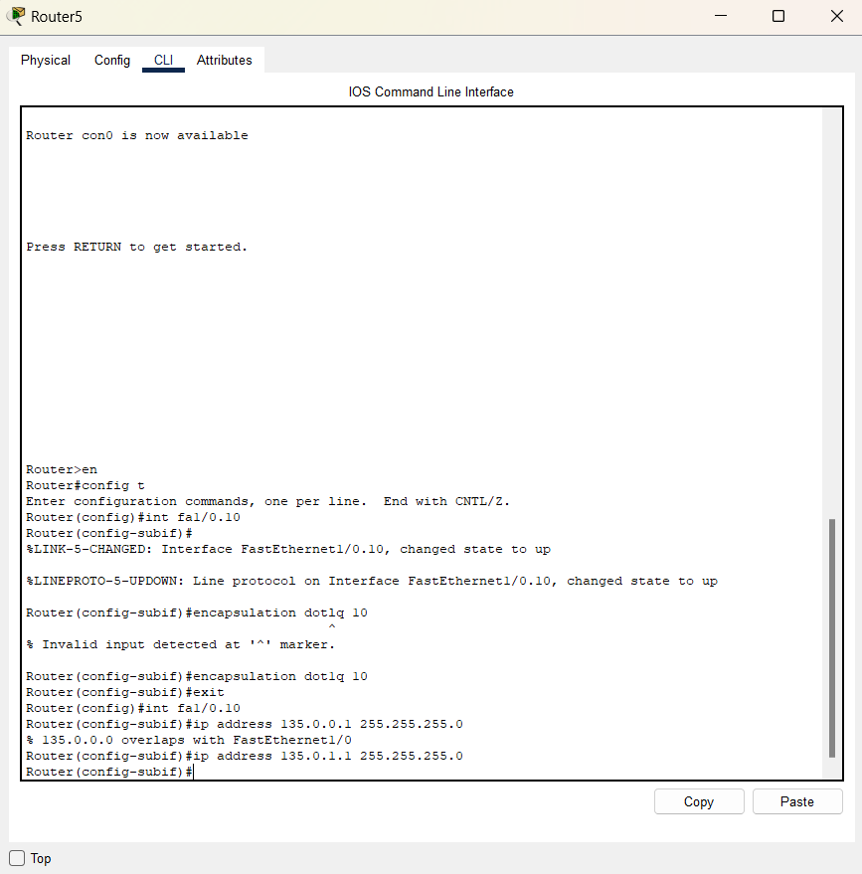

Switch 7:
